Measuring the height of Saguaros using a clinometer
Ranger Anna is with a group of high school students from Saguaro Academy. They went out to the desert to assess and measure the height of several saguaros for the 2020 Saguaro Census. The saguaros that they have encountered so far are below 2 meters or are just slightly above 2 meters and they were able to just use the meter stick that they brought with them.
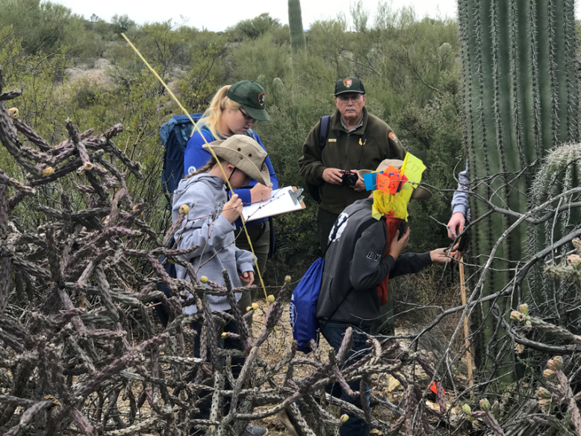
Young students measuring the height of a saguaro using meter sticks
However, they then encounter a taller saguaro, and they will need to estimate its height using a clinometer. Ranger Anna positions herself 10 meters away from the saguaro. Looking through the clinometer to the top of the saguaro, she notes that the line runs through the number at the right which is 45 degrees. She similarly obtains a measure of 30 degrees for the bottom of the saguaro.
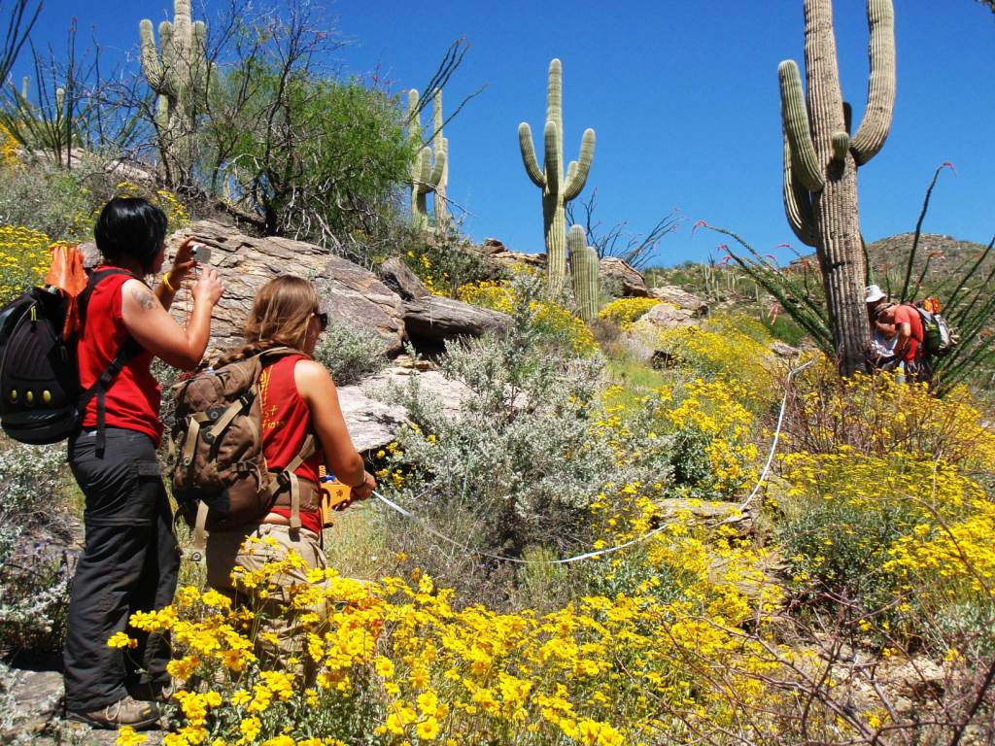
Park staff using a clinometer to find the height of the saguaro
Using the information above, find the height of the saguaro. Show all your work.

Extension
If Ranger Anna positions herself 12 meters away from the saguaro instead of 10 meters, what is the estimated height of the saguaro? For this exercise, assume that she still observed the same values in the clinometer for the top and bottom of the saguaro.

